Dissertation Proposal for: The Physiological Effects of Ocean Acidification on Multiple Life History Stages of the Pacific Oyster, Crassostrea gigas
Emma Timmins-Schiffman

INTRODUCTION
Changes to the environment
Wide-scale climatic changes are projected for the world’s oceans over the next century, fundamentally changing the habitat and environment for marine organisms. The near-shore habitat of the eastern Pacific Ocean will be altered in some ways that will be consistent with global changes and other ways that are regionally unique. Sea surface temperature in the North Pacific is projected to increase 1.2°C by the middle of the 21st century (King et al. 2011). There are also projected changes to intensity and patterns of upwelling along the U.S. west coast, which regulates much of the near-shore productivity (Diffenbaugh et al. 2004; Snyder et al. 2003). Sea level rise is expected to increase worldwide, with estimates for the outer Washington coast ranging between 4 and 29 cm (Mote et al. 2008). These environmental changes will promote commensurate shifts in marine populations that could result in acclimatization via physiological changes, range shifts, or adaptation through differential fitness within a population (e.g. Réale et al. 2003; Whitehead et al. 2010; Banks et al. 2010). Depending on the changes that occur, natural populations could undergo restructuring in terms of location in space and genomic resources via changes in allele frequencies. Some of this restructuring could lead to widespread population depletions, which may harbor less adaptive potential to withstand or recover from significant and sustained climate change (Faurby et al. 2010). The sensitivities of populations will be determined by how significantly the species’ habitats, resources, and physiologies will change upon exposure to a shifting climate.
Among the projected changes for the coming century, ocean acidification is expected to be one of the more dramatic alterations. Ocean acidification occurs when carbon dioxide dissolves in seawater and its dissolution produces hydrogen ions in solution, thus decreasing the ocean’s pH. Carbon dioxide is the greatest contributor to greenhouse gases and its concentration has been increasing at an accelerating pace in the past couple of decades (IPCC 2007). Global atmospheric concentrations of CO₂, methane, and nitrous oxide are much greater now than they have been for thousands of years (IPCC 2007). Oceanic pH has already decreased an average of 0.1 pH units and is projected to decrease 0.14 to 0.25 units more due to uptake of anthropogenic carbon in the form of CO₂ (IPCC 2007). There is already low pH in the California Current System as a direct result of upwellings that are high in nutrients and dissolved CO₂ (Hauri et al. 2009). Similarly, in Puget Sound, WA present-day decreases in pH due to ocean acidification are between 0.05 and 0.15 pH units (Feely et al. 2010).
Carbon dioxide dissolution in seawater prompts decreases in pH, increases in total inorganic carbon (DIC), decreased calcium carbonate saturation state (Ω), but does not change total alkalinity (TA). These four water chemistry components – pH, DIC, Ω, and TA – are all interrelated and can have a variety of different effects on aquatic organisms. pH is the negative log of the hydrogen ion concentration in water and thus decreases with increasing H⁺ concentration. DIC is the total amount of inorganic carbon in seawater and is partially comprised of CO₂ in solution. The concept of TA is slightly more complicated as it is affected by a multitude of elements dissolved in water. Grossly, TA changes with the balance between electron donors and receptors and can buffer some of the corrosive effects of increasing dissolution of CO₂. Since CO₂ increases the concentrations of both electron donors and acceptors as it dissolves, TA has not net change with increased CO₂. TA is mostly affected by biological activity and thus its measurement can be complicated in a closed system or in the near-shore environment. TA, DIC, and pH all affect the saturation state of calcium carbonate (CaCO₃) in seawater. As Ω decreases below 1, water becomes undersaturated with respect to CaCO₃ and it becomes more difficult for calcifying organisms to form and maintain CaCO₃ structures.
Carbonate chemistry dynamics are very different in the near-shore environment compared to the open ocean. In the near-shore upwelling zone, biological activity/respiration is able to rapidly reduce dissolved inorganic carbon (Fassbender et al. 2011). Organic matter respiration can cause near-shore, upwelled waters to become undersaturated with respect to aragonite, a polymorph of CaCO₃. The subsequent dissolution of aragonitic structures increases TA and DIC (Fassbender et al. 2011). In the California Current System, upwelling causes the saturation state of aragonite to vary seasonally, becoming very low in coastal waters in the summer (Hauri et al. 2009).
Concurrent with changes in ocean chemistry, human activity is also contributing to the degradation of the near-shore environment through increasing release of contaminants. Ecosystems are exposed to influences and contaminants from proximal human populations that threaten to disrupt the physiology and long-term population viability of endemic organisms (Wirgin et al. 2011; Letendre et al. in press). For example, continuing input of pollution into Puget Sound is one of the top two immediate threats to the ecosystem (PSP, 2008). Other stressors such as ocean acidification or hypoxia could compound the effects of pollution on aquatic populations that come with high human population densities.

Organism response
Marine invertebrates, as environmental conformers, have sensory and response mechanisms to survive changes in the environment. Changes in temperature, salinity, and pH have proven to elicit specific reactions in a variety of physiological responses in invertebrates (Rodriguez-Lanetty et al. 2009; Lockwood & Somero 2011; Lannig et al. 2010). Through sensing environmental change and integrating responses at the molecular and whole organism levels, animals such as the Pacific oyster, Crassostrea gigas, are able to maintain homeostasis in a variable marine environment. Projected environmental changes to the global ocean foresee acidification and warming that will be novel stresses for contemporary biota (IPCC 2007). Oysters may or may not have the physiological resources necessary to weather these changes.
Ocean acidification has so far proven to elicit a range of response in marine invertebrates from reductions in shell size and strength to differing protein expression profiles. Responses to OA can also be life stage-specific, which could augment or dampen the negative effects of climate change. In an ocean with higher concentrations of CO₂, the dissolved gas can more readily diffuse across membranes and reach equilibrium between intra- and extracellular spaces (Fabry et al. 2008). The CO₂ can then react with intracellular fluids to decrease intracellular pH (pH_{i}) for which there are limited physiological counteractions (Fabry et al. 2008). Some invertebrates are able to buffer changes in pH_{i} and pH_{e} (intra- and extracellular pH, respectively) with the bicarbonate ion, HCO₃⁻ (Pörtner et al. 2004). Organisms usually effect this change through dissolution of CaCO₃ structures (Marchant et al. 2010; Miles et al. 2007; Spicer et al. 2007). Marine invertebrates also possess a number of membrane proteins, such as v-type H⁺-ATPase, Na⁺/H⁺- and Na⁺-dependent Cl⁻/HCO₃⁻ exchange, that can contribute to maintaining pH_{i} homeostasis (Pörtner et al. 2004). The physiological and energetic toll of maintaining a specific pH_{i} depends in part on whether an organism removes a fixed number of H⁺ from their calcification fluid (energy use will go up with OA) or whether they maintain a fixed ratio of H⁺ across their calcification compartment membrane (energy use will go down; Ries 2011).
Larval invertebrates seem to be more susceptible to environmental changes compared to adult life stages and thus may prove to be the bottleneck when it comes to acclimatization or adaptation to climate change. Even when there are no apparent mortalities or abnormalities at different pCO₂ treatments, physiological shifts between treatments can be measured at the molecular level (Todgham and Hofmann 2009). Typically, however, larval shell corrosion, pitting, and decreases in size are apparent at lower pH treatments as seen in mussels(Mytilus edulis, Bechmann et al. 2011) the Sydney rock oyster, Saccostrea glomerata (Watson et al. 2009; Parker et al. 2010), the Pacific oyster, C. gigas, (Kurihara et al. 2007; Parker et al. 2010), the brittlestar (Ophiothrix fragilis , Dupont et al. 2008), sea urchins (Paracentrotus lividus, Martin et al. 2011), and barnacles (Semibalanus balanoides, Findlay et al. 2009). Underlying these morphological changes under OA conditions are physiological shifts to cope with a changing environment. At pH 7.6 compared to 8.1, larval barnacles (Balanus amphitrite) changed expression of 9 proteins related to energy metabolism, molecular chaperones, and respiration (Wong et al. 2011). Larvae of the urchin Strongylocentrotus purpuratus responded to low pH with an increase in routine metabolic rate, a decrease in scope for growth, and changes in expression of genes related to ion transport, calcification, metabolism, and the cellular stress response (Stumpp et al. 2011a and 2011b). Similarly, in the larvae of the urchin Paracentrotus lividus, decreased pH caused a change in expression of genes involved in development and biomineralization (Martin et al. 2011). These transcriptomic and proteomic shifts may signal a stress response, but they are also evidence of the organism’s ability to launch a plastic response and possibly acclimatize to OA conditions (Martin et al. 2011; Wong et al. 2011). Larval S. glomerata exposed to high pCO₂ have better survival and more normal growth when the parents are conditioned under similar high pCO₂ conditions (Parker et al. in press), implying that some of these negative effects may be mitigated due to maternal effects.
Adult marine invertebrates are also adversely affected by ocean acidification in terms of primary effects and in how they are able to cope with subsequent stressors. Many invertebrates seem to have physiological mechanisms to respond to OA, but the response is metabolically costly. Cuttlefish (Sepia officinalis) can maintain acid-base balance under high CO₂ conditions, but the effort most likely comes at an energetic cost from the necessary rapid ion transport of HCO₃⁻ (Gutowska et al. 2010). After 2 weeks of exposure to water at pH 7.5 (compared to controls at 8.3), adult Eastern oysters, Crassostrea virginica, increased expression of oxidative stress proteins (Tomanek et al. 2011). In Mytilus edulis low pH also caused decreased shell length, mass, and NH₄ secretion, and increased metabolic rates, the latter two contributing to energy loss (Thomsen & Melzner 2010). Also in M. edulis, Michaelidis et al. (2005) found that the mussels were able to regulate pH_{i}, but at a cost of decreased metabolic rate and growth. Low pH also caused increased stress and basal metabolic rate in the bivalve Laternula elliptica (Cummings et al. 2010). In some organisms, OA even causes a reduced ability to feed. The limpet Patella vulgata experienced shell dissolution (resulting in increased extracellular calcium) and radular damage at pH 7.6 after only 5 days (Marchant et al. 2010).
Across taxa, evidence points to a potential impaired physiological response if marine invertebrates are exposed to reduced pH and another stressor. After one month of incubation at an elevated pCO₂ (pH 7.7), adult C. gigas exposed to acute warming had a stronger increase in standard metabolic rate compared to controls (Lannig et al. 2010). In juvenile pteropods (Limacine helicina), elevated temperature and pCO₂ affected mortality and shell integrity (Lischka et al. 2011). Short-term (1 week) and long-term (6 months) exposure to acidified conditions results in immune suppression for the sea star Asterias rubens (Hernroth et al. 2011). In A. rubens, the molecular chaperone Hsp70 is upregulated after a 1 week exposure, but is suppressed after 6 months’ exposure; coelomocytes show reduced MPK-p38 activity after 6 months; and there are fewer coelomocytes at both time points and reduced phagocytic activity after 6 months (Hernroth et al. 2011). These multiple metrics of immune response suggest that A. rubens would launch a less effective immune defense if challenged under OA conditions.
Environmental stressors rarely occur in isolation, and exposure to low pH can deplete an invertebrate’s ability to launch an effective stress defense against a second stressor. Pacific oysters inhabit estuaries and near-shore environments that are frequently environmentally variable and heavily impacted by human activity. In addition to increasingly acidic waters, oysters could also experience exposure to pesticides and other environmental contaminants. The eastern oyster, C. virginica, showed an increased expression of genes related to the electron transport chain (ETC) in response to metals, organic pollutants, and nutrients (Chapman et al. 2011). Pentachlorophenol is a pesticide that acts as an uncoupler of mitochondrial phosphorylation leading to discharge of the chemiosmotic gradient formed by the ETC (Weinbach 1954). Recently, some post-rainfall concentrations of PCP in Puget Sound were found to be above those deemed safe for water quality (DOE 2011). C. gigas has a limited ability to biotransform PCP, so most of the chemical is depurated and some is metabolized in an acute exposure (Shofer & Tjeerdema 1993). Coupled with OA, chemicals such as PCP could pose a significant environmental stress to oysters and other near-shore invertebrates.

Ocean acidification and other environmental shifts associated with climate change will create an aquatic environment characterized by novel stresses to marine invertebrates. In order to understand how individuals and populations will react to these environmental changes, a suite of biological responses need to be characterized. Life-stage specific responses to environmental change also need to be considered since these responses can encompass a wide range of physiological capabilities and responses. Full characterization of an organism’s response could aid in informing policy and management in protecting natural and commercially relevant populations in a changing climate.

OBJECTIVES
- To characterize how ocean acidification affects larval oyster growth, development, calcification, and physiology through controlled laboratory experiments with different levels of pCO₂;
- To discover how exposure to acidic conditions affects juvenile oyster response to a secondary stressor by measuring growth, gene expression, protein expression, and response to heat shock;
- To quantify how conditioning of adult oysters in acidic water affects their fitness (measured by gonad development and larval survival).

METHODS
Objective 1: Larval oysters and OA
General Plan
Larval Pacific oysters will be exposed to 3 different concentrations of pCO₂: 400 (ambient/control), 700, and 1000 µatm. The exposure will begin at fertilization and continue until 4 days post-fertilization. During the exposure, water chemistry will be measured to track changes in alkalinity, pH, and DIC as well as salinity and temperature. At 1, 6, 24, and 72 hours post fertilization (hpf), samples will be taken from each treatment for analyses of density, mortality, developmental stage, size, and calcification. At 96 hpf, terminal samples will be taken from all treatments for transcriptomic analysis.

Specific Methods
Friday Harbor Labs has a flow-through ocean acidification system designed for challenge experiments (Figure 1) and equipment to measure total alkalinity (TA), dissolved inorganic carbon (DIC), and pH. Briefly, CO₂ is removed from the incoming water so that it is at a high pH and can easily be manipulated for different treatments. Carbon dioxide is also stripped from incoming air and the CO₂-free air is mixed with pure CO₂ from a canister in each treatment tank with a Venturi injector attached to a Honeywell controller. The water from the treatment tank is pumped past a DuraFET pH probe, which is also attached to the Honeywell. Once calibrated using spectrophotometric pH measurements (see below), the controller can regulate the relative amounts of CO₂ and CO₂-free air that are injected into the treatment water. This water is circulated through the individual larval microcosms (6 per CO₂ level) and leaves the system as the water in the containers turns over.
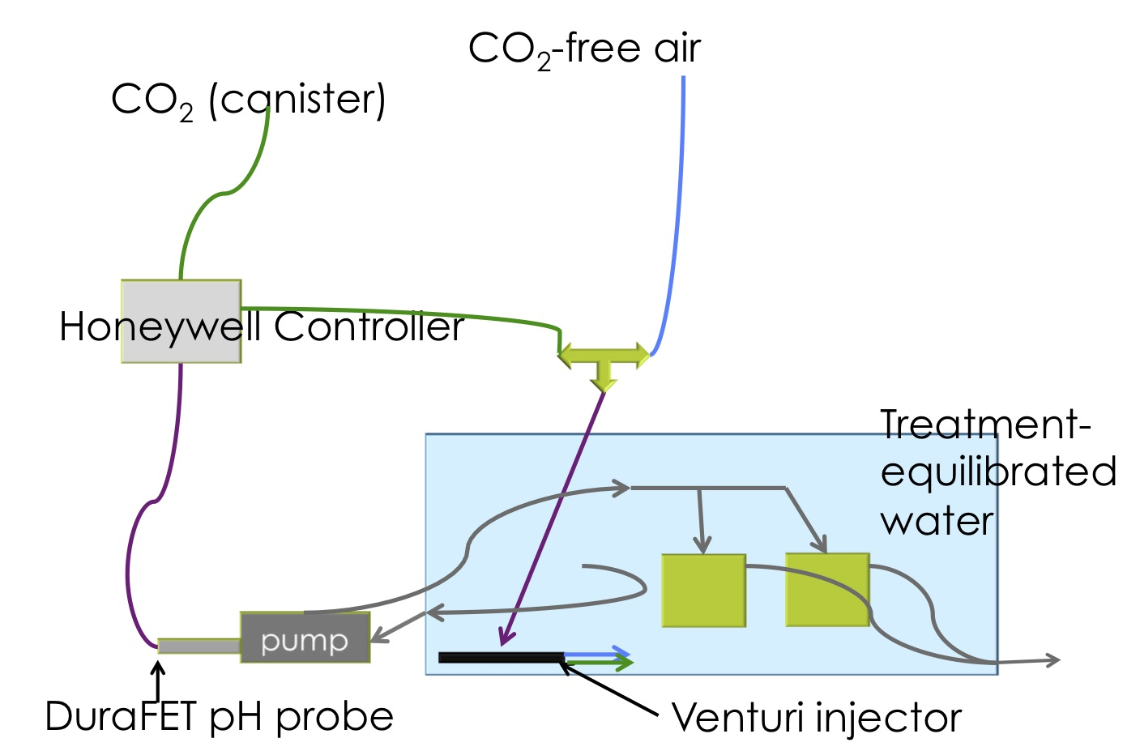
Figure 1. Diagram of the flow-through system at Friday Harbor Labs. The gray arrows indicate water flow, purple arrows are information flow, and blue and green arrows are gas flow.

TA, DIC, pH, temperature and salinity will be measured daily in the treatment water that is flowing into the microcosms. On sampling days, TA, pH, temperature, and salinity will be measured in 2 of the 6 microcosms. All methods for measuring carbonate chemistry parameters will follow the SOPs in Dickson et al. 2007. TA will be quantified using a Gran titration while measuring solution pH and electrode voltage and will be normalized against certified reference material (Dickson et al. 2007, SOP 3b). DIC will be measured by acidifying a known amount of seawater so that all inorganic carbon becomes CO₂. The CO₂ will be measured with infrared (Dickson et al. 2007, SOP 2). pH will be measured spectrophotometrically (Dickson et al. 2007, SOP 6b) by filling a glass cuvette with seawater and letting it overflow at least half its volume. The cuvettes will be equilibrated to 25°C using a water bath. Seventy-five µL of meta-cresol purple (2mmol/L, pH about 7.9) will be added to each cuvette and then placed in an ocean optics spectrophotometer, correcting for background seawater absorbance. Temperature and dye-corrected pH will be calculated based on SOP 6b. Temperature will be measured with a temperature probe and salinity with a salinity meter.
Adult Pacific oysters (approximately 16) will be collected at low tide from Argyle Creek in Friday Harbor, WA. Oysters will be strip spawned that morning, keeping eggs and sperm separate but pooling within gamete type. Approximately 90,000 eggs will be placed into fertilization vessels (8 per treatment) and fertilized with a small volume of diluted sperm. Six of the fertilized replicates will go into pre-equilibrated water in the microcosms and 2 will be put into separate 50 mL Falcon tubes also containing pre-equilibrated water. The microcosms will be left static for 24 hours. At 1 and 6 hpf, aliquots containing greater than 50 embryos will be taken from each of the Falcon tubes and fixed in 4% paraformaldehyde (PFA) in filtered sterile seawater at pH 8 to later determine developmental stage in each treatment.
At 24 hpf, larval microcosms will be emptied and cleaned and larvae will be sampled for microscopy by fixing them in 4% PFA. Samples will also be taken for immediate determination of density, mortality and, using scanning electron microscopy, shell morphology. After sampling, remaining larvae will be returned to their cleaned container. The sampling and cleaning will be repeated at 72 hpf. At 96 hpf, larvae from 2 microcosms from each treatment will be sieved out and flash frozen in liquid nitrogen.
Transcriptomics will be accomplished using the candidate gene approach. Expression level of genes for shell mineralization (MSP130-related protein), oxidative stress (superoxide dismutase, glutathione peroxidase, and peroxiredoxin 6), molecular chaperones (heat shock protein 70), and energy metabolism (ATP synthase, citrate synthase) will be measured. These gene classes are chosen based on previous research that has found their expression levels to vary in other species of invertebrate larvae in similar experiments (Kurihara et al. 2007; Tomanek et al. 2011; Stumpp et al. 2011b; Wong et al. 2011).
Larval size across treatments will be analyzed using analysis of variance (ANOVA) with treatment and container as fixed factors followed by Tukey’s HSD. Developmental stage, density, and calcification will be analyzed using a generalized linear model (GLM) to account for different sample sizes. All gene expression data will be normalized to the housekeeping gene elongation factor 1a and will be compared to the control treatment using a student’s t-test.

Objective 2: Juvenile oysters and multiple stressors
General Plan
Juvenile oysters will be preconditioned to one of 3 pCO₂ levels – 400 (ambient/control), 700 or 1000 µatm – for either 1 or 2 weeks. The oysters from each of these 6 pCO₂ treatments will then be exposed to one of two environmentally relevant concentrations of pentachlorophenol (PCP) for one week or will just be placed in a clean water bath (control). Oyster response to heat shock will be quantified across treatments. After the PCP exposure, gill tissue will be excised from some of the oysters for histology, transcriptomic analysis, and proteomics. Shells will also be collected for shell protein composition.

Specific Methods
At the start and end of the experiment, all oysters (n=1080) will be measured for shell height, depth, and width. Juvenile oysters will be exposed to one of 3 levels of pCO₂ – 400, 700, or 1000 µatm – for either 1 or 2 weeks (see Figure 2) with 3 replicates of 60 oysters per treatment. Treatment water will be pre-equilibrated by supersaturating some water with CO₂ and mixing it with water of a lower CO₂ content. Before daily water changes, the treatment water will be measured for pH, TA, salinity, and temperature. Water in the oyster holding containers will be measured for pH, TA, temperature and salinity daily (see Objective 1 for specific methods). After the 1 or 2 weeks, 60 oysters from each pCO₂ condition will be divided into 3 replicates of 20 and exposed to either 0.05 or 0.15 µg per liter (average and high environmental concentrations, respectively; from DOE 2011) of pentachlorophenol (PCP) or no PCP (control). After 1 week of PCP exposure, the oysters’ response to the dual stressors of ocean acidification and environmental contaminant will be quantified via a variety of metrics, as described in detail below. The metrics include, mortality, histology, transcriptomics, proteomics, and response to heat shock. The same 20 oysters will be sampled within each treatment for histology, shell protein content, transcriptomics, and proteomics (Figure 3).
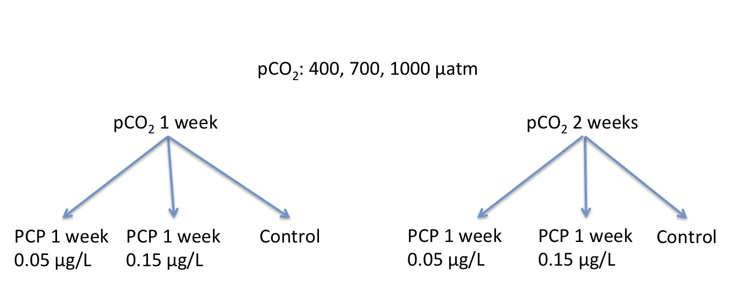
Figure 2. Diagram of experimental plan for exposure for Objective 2.

Mortality: Mortality in each treatment will be determined daily. An oyster will be considered dead when it is gaping and does not close its valves when removed from the water. All dead oysters will be measured as described above.

Histology: At the end of the PCP exposure, a cross section including gill tissue and digestive gland from 20 oysters from each of the 18 treatments will be excised and examined histologically for evidence of treatment effects (Figure 3). Gill tissue will be fixed in Invertebrate Davidson’s solution (Shaw & Battle 1957) and dehydrated through an ascending ethanol series. The gill tissue will then be embedded in paraffin, sectioned at 5 µm, and stained with Ehrlich’s haematoxylin and eosin. Tissue will be examined for signs of hemocyte influx, metaplasia, abnormal cell morphology, and unhealthy or dying tissue. Immuno-fluorescent antibody test will also be preformed to visualize Hsp70 expression (Clegg et al. 1998; Elston & Leibovitz 1980).
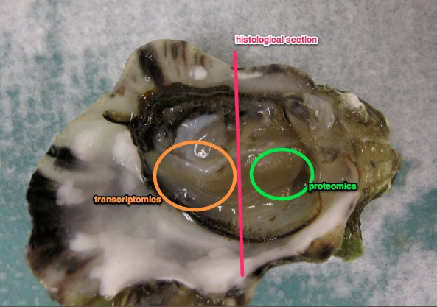
Figure 3. Schematic of oyster sampling protocol – the pink line represents the cross section that will be taken for histology; the green circle encompasses the gill that will be sampled for proteomics; the orange circle is around the gill that will be dedicated to transcriptomics.

Shell Protein Content: Shell protein chemistry from 20 oysters from each of the 18 treatments will be analyzed to determine the differences in shell growth between treatments. Calcium carbonate crystals in mollusc shells contain proteins between the structures. Analysis of the amino acid contents of the oyster shells between treatments will indicate if there is a treatment effect on shell chemistry and possibly energy allocation to growth (Penkman et al. 2008).

Transcriptomics: At the end of the PCP exposure, 20 oysters from each treatment will be sampled for gene expression analysis. Gill tissue will be excised from each oyster using sterile techniques and will be flash frozen on dry ice for later RNA extraction using Tri Reagent. From the high PCP-exposed and non-PCP-exposed oysters from each pCO₂ treatment (12 experimental exposures total), equal concentrations of RNA will be pooled within treatment groups and will be sequenced via next-generation sequencing (NGS) using SOLiD3 sequencing (Applied Biosystems). NGS allows for sequencing of the entire transcriptome without the bias of choosing which genes the investigator believes a priori will be expressed differently. The transcriptomes will be assembled in CLC Genomics Workbench onto a C. gigas backbone from publicly available sequence and ESTs and will be compared for differences in gene expression between treatments (e.g. Jeukens et al. 2010). In CLC, sequence counts are transformed into reads per kilobase per million mapped reads, which standardizes the sequence counts as functions of the contig length and the absolute data set size (Jeukens et al. 2010). Only contigs with 10 or more reads will be used in the statistical analysis (Jeukens et al. 2010). For the contigs that make this cut-off, expression between treatment groups will be analyzed using a Chi square test with a correction for multiple hypotheses testing using Qvalue (Storey 2002). The genes that show a difference in expression will be entered into a blastx search against the SwissProt database (http://www.ebi.ac.uk/uniprot/) in NCIB (http://www.ncbi.nlm.nih.gov/). Genes will be annotated with a protein name if they return a blast hit with an e-value of at least 10⁻³⁰.
From all the treatment groups, RNA will be reverse transcribed into complementary DNA (cDNA) for a targeted gene approach. Primers will be found in the literature or designed for C. gigas genes involved in shell mineralization, oxidative stress, molecular chaperones, and energy metabolism (see above methods for Objective 1), as well as acid-base balance (Spicer et al. 2007) and the electron transport chain (Weinbach 1954). These genes are chosen based on the molecular pathways that have previously been shown to be disrupted in organisms exposed to OA conditions or PCP. Primers will also be designed from the NGS sequence for genes that show evidence of significant up- or down-regulation between treatments. Gene expression differences between treatments will be analyzed using ANOVA, with treatment and replicate as fixed factors.

Proteomics: At the end of the PCP exposure, gill tissue will be dissected from 20 oysters from each of the 18 treatments using sterile techniques. Proteins will be extracted from these tissues and will be analyzed using 2-dimensional dodecyl sulfate-polyacrylamide gel electrophoresis (SDS-PAGE) (Clegg et al. 1998; Tomanek et al. 2011). Separate gels will be run for each oyster protein extraction, but during the gel image analysis, images of the gels will be combined to determine the mean volume for each protein spot within treatments (described in Tomanek et al. 2011). Gel spots between treatments will be compared using a t-test (Tomanek et al. 2011). If the gel electrophoresis shows potentially interesting difference in protein expression between certain treatments, then these protein spots will be cut out and sequenced.

Heat shock response: Initially, oysters from the same group used for the exposure described above will be used to determine the lethal heat treatment (LHT; Clegg et al. 1998). Ten oysters each will be exposed to either 42, 43, 44 or 45 °C for 1 hour and then returned to ambient conditions for 1 week. The LHT will be the temperature that causes 100% mortality by 1 week post exposure (Clegg et al. 1998). The sublethal heat shock temperature (SLT) will be 6°C below the LHT and will be tested with 10 oysters as described for LHT, except there should be no mortality up to 1 week post exposure.
After the PCP exposure, 35 oysters from each of the 18 treatments will be exposed to SLT for 1 hour and then returned to ambient conditions. At 3 time points following SLT – immediately (0 hours), 2 days, and 14 days – oysters from each treatment will be exposed to LHT for 1 hour. Five oysters will have been sampled immediately following the SLT: gill tissue will be excised (as described in “Transcriptomics”) and gene expression of hsp70 as well as protein expression of Hsp70 will be measured. For each time point, 10 oysters will be exposed. Five of these oysters will be sampled immediately following LHT and 5 will be returned to ambient conditions for 1 week. Mortality will be assessed and gill tissue will be excised at each time point for hsp70 expression. Hsp70 protein expression will be assessed using a western blot.
Differences in hsp70 and Hsp70 expression will be explored using ANOVA with the 2 treatments (PCP and OA) and container of origin as fixed factors. Percent mortality from heat shock will similarly be analyzed using ANOVA.

Objective 3: Adult oyster fitness under OA
General Plan
Adult oysters from selectively bred hatchery stock and from naturally set wild populations will be conditioned for 3 months in water from either the lower (low pH) or upper water (high pH) intakes to the Quilcene Hatchery in Dabob Bay, WA. These 2 water intakes have real-time pH monitoring already established and frequently have distinct pH profiles (B. Eudeline, pers. comm.). After the 2 months, gonads from a subset of the oysters will be fixed for histological assessment of gametogenesis. The adults will be genotyped and spawned in the following crosses (UW = upper water intake, LW = lower water intake): UW wild x UW wild; UW bred x UW bred; LW wild x LW wild; LW bred x LW bred; UW wild females x LW wild males; LW wild females x UW wild males. The latter two crosses will be used to determine possible maternal effects of OA exposure while the other crosses will give evidence of overall parental influence on larval fitness. After fertilization of embryos, larvae will develop for 24 hours until the D-hinge stage where calcification begins. At this point, larvae from all the crosses will be sampled and fixed to determine developmental stage, size, and calcification. D-hinge larvae will also be preserved for genotyping to determine genotype-dependent survival.

Specific Methods
Adult oyster broodstock will be acclimated in water originating from either the upper or lower water intakes at the Quilcene Hatchery in Dabob Bay, WA for two months. 150 wild oysters collected from Big Beef Creek, WA and 100 hatchery broodstock selectively bred for fast growth will be conditioned in water from each intake. By acclimating the oysters inside the hatchery, they will be exposed to different pH profiles while temperature and food are controlled. Concurrent to the oyster acclimatization, water will be monitored for pH, temperature, and salinity. Samples for TA analysis will be taken bi-weekly. At the end of the acclimatization, gametogenesis will be assessed in 20 wild and 20 selectively bred oysters from each water intake (total = 80 oysters). Gonad tissue will be dissected from the oysters and will be fixed in Invertebrate Davidson’s solution for 24 hours and then processed for routine paraffin histology. Five µm sections will be stained with Ehrlich’s haematoxylin and eosin. The histological sections will be assessed for stage of gametogenesis, i.e. gonad-somatic index (GSI, the ratio of non-gametic tissue to gametes), and diameter of 100 oocytes per female oyster will be measured (Li et al. 2000). Gonad samples will also be sent out for analysis of glycogen, protein, and lipids (Li et al. 2000). Gametogenesis will be analyzed using PCA: the objects will be individual oysters and the variables will be whether the oyster is wild or hatchery bred, GSI, average diameter of oocytes, amount of glycogen, protein, and lipids.
Six crosses will be performed to determine the potential effects of parent origin (hatchery vs. wild), the effects of pre-conditioning to different pH profiles, and the specific maternal effects of different pH acclimatization. Four crosses will be made within parent provenance type and within acclimatization water origin, e.g. lower water intake wild females crossed with lower water intake wild males. Two crosses will be made within the wild oysters between water intakes to test specifically for maternal effects: LW wild females by UW wild males and vice versa.
All broodstock will be genotyped at 10 polymorphic single nucleotide polymorphisms (SNPs). The power of parentage assignment for these 10 SNPs will be tested in Cervus (http://www.fieldgenetics.com/pages/aboutCervus_Functions.jsp). Primers will be designed from SNPs identified for the Pacific oyster in Sauvage et al. (2007). After spawning is induced, a section of mantle tissue will be dissected using sterile technique from each oyster that spawned. The tissue will be rinsed with deionized water to remove any gametes or other biological material from the other oysters and will be stored in 90% ethanol. Primers will be designed to create the smallest amplicon possible (to increase reaction efficiency) while retaining specificity for that particular SNP (Liew et al. 2004). The SNPs will be analyzed using high-resolution melt analysis (HRM).
Larvae will be raised in ambient seawater for 24 hours. At the end of 24 hours, approximately 100 larvae from each cross will be fixed in 4% PFA in sterile filtered seawater at pH 8 to measure size, morphology, and calcification. Approximately 100 larvae will be preserved in 90% ethanol for DNA analysis. Size and morphology will be assessed using a microscope at 20x and by taking pictures of the enlarged image to measure. Calcification will be qualified using double polarization of light to determine if the larvae are fully, partially, or uncalcified. Size, morphology, and caclfication will be analyzed using a GLM. DNA will be extracted from individual larvae (as described in Wang et al. 2009) and amplified using HRM for the 10 SNPs used to genotype the parents. The distribution of SNPs in the 1-day old larvae will give a picture of the possible effects of parent acclimatization on fitness. The absence of certain genotypes in some of the crosses may indicate that these genotypes are not as fit under certain pH conditions. Parentage analysis and allele frequencies will be done in the program Cervus.

INTERPRETATION
Objective 1 interpretation
The outcome of this experiment will give insight into how OA affects the development of C. gigas larvae. They hypothesis of this experiment is that OA will negatively affect oyster larvae through increased physiological demands. If larvae reared at higher pCO₂ fare worse than those in the control treatment, there will be evidence for the detrimental effects of OA on development. If larval development is affected, it can be extrapolated that they may not develop into adults or that they will not be fit adults. If no difference is found between treatments or if the control treatment does the worst of all the treatments then it could be deduced that C. gigas larvae thrive in or are not affected by an OA environment. However, higher pCO₂-reared larvae doing better could be an indication that increased growth or lack of up-regulation of genes masks faster development to reach a more robust life history stage to better combat the detrimental environment. Another complication with the gene expression data could be that the expression of specific genes is not well correlated with translation into functional proteins. It is usually the case that up- or down-regulation of genes corresponds to differential protein expression (e.g. Clegg et al. 1998), but it is hard to support this assumption without protein expression analysis.

Objective 2 interpretation
The goal of this objective is 2-fold: 1. To determine the effects of combined stressors on juvenile C. gigas in a novel experiment and 2. To determine if OA and PCP exposure act synergistically, additively, or antagonistically on the metrics measured. In terms of the OA exposure, the greatest effects will probably be seen in the transcriptome and proteome analyses since juvenile oysters are expected to be more resistant to the effects of OA. Changes in RNA and protein expression profiles between treatments will elucidate the physiological effects of different OA treatments on C. gigas juveniles. The addition of PCP will give insight into the same processes and may also affect tissue histology. This experiment is designed to give a holistic interpretation of how the two chosen stressors affect C. gigas at multiple scales – from genes, to protein, to functional morphology (adaptive potential). The concentrations chosen for the PCP exposure will also indicate whether current environmental levels of the contaminant are harmful to aquatic organisms.
The heat shock response metric will provide support for determining how exposure to other stressors affects acclimation ability. It also will provide insight into the physiological reaction to a third stressor, which is environmentally relevant since in a natural setting oysters are frequently exposed to multiple coinciding stressors. An inhibited ability to launch a heat shock response will indicate that oysters are physiologically ill prepared to survive a rapidly changing environment. If the PCP and OA exposure have no effect on mortality in the heat shock response, then it is probable that Pacific oyster juveniles have a sufficiently plastic physiological response to survive multiple stressors.

Objective 3 interpretation
Objective 3 is designed to determine if adult exposure to low pH conditions affects the fitness of C. gigas. It is hypothesized that exposure to a low pH will adversely affect gametogenesis in the oyster as well as decrease the viability of offspring. Both of these factors would reduce population fitness in a natural setting. Decreased gametogenesis and less investment in reproduction could be a strategy by the oyster to weather an environmental change and 1. not produce larvae in a hostile environment where they may not survive or 2. reserve their own resources in the hopes of reproducing when conditions get better. If no effect between pH backgrounds is found, then C. gigas may have a plastic enough response and/or depend enough on sweepstakes selection that environmental conditioning does not matter.
The comparison between wild and selectively inbred oysters could indicate if a selective advantage is conferred either from natural selection in a variable environment or from a planned breeding program. The distribution of parental SNPs in the D-hinge larvae will give an indication of the overall reproductive success of the spawned oysters. A decrease in SNP diversity between generations could be evidence of a bottleneck caused by acclimation conditions. Parker et al. (in press) found that selectively bred Saccostrea glomerata produced better performing larvae than their wild counterparts in a similar experiment. If wild C. gigas produce better larvae and have more pronounced gametogenesis, then generations of selection in an environment where multiple variables fluctuate on a variety of temporal scales may provide the selective advantage necessary to survive changes in ocean pH. If the opposite is true and selectively bred oysters perform better, then hatchery supplementation programs could help to maintain healthy stocks of oysters and other molluscs in Puget Sound.

SIGNIFICANCE
The outcomes from the experiments outlined above will provide a comprehensive picture of how ocean acidification and other environmental stressors affect multiple life stages of the Pacific oyster, Crassostrea gigas. From this perspective, any outcome of these experiments will be of both ecological and economic merit. Environmental stresses, including OA, temperature and contaminants, are of concern both locally and globally and Pacific oysters provide an easy model by which to study them. Pacific oysters are also found in many near-shore environments worldwide, where they are farmed for human consumption. Thus, the results of this experiment have the potential to have a worldwide impact.
Since global climate change, including OA, is already occurring, these results will show to what degree an ecologically and economically important species will be affected. It is important to consider the effects of climate change on all life stages of an organism since certain stages may be affected in quantitatively and qualitatively different ways. Even if these experiments show that there is no effect of the stressors investigated on C. gigas, the results will still be valuable
Objective 1 will give a detailed account of how Pacific oyster larvae are affected by ocean acidification. Larval forms of marine invertebrates are typically more susceptible to the effects of OA and other climate change. Previous studies have shown that C. gigas larvae suffer developmental delay and abnormal physiology under high CO₂ conditions (Kurihara et al. 2007). The data from this objective will contribute to the growing body of knowledge on Pacific oyster larvae and OA by providing insight into impacts on essential physiological processes. A better understanding of OA effects on these processes could inform mitigation by managers and hatcheries.
Objective 2 will elucidate the integrated response of C. gigas juveniles to multiple stressors associated with climate change and increased human use of the ecosystem. Every level of the organism response will be assessed in this objective – transcriptomic, proteomic, and functional morphology – to see how environmental conditions are affecting organism health and survival and the mechanisms by which that survival occurs. The molecular and physiological resources used to combat a changing climate will be uncovered in detail through analysis of gene regulation and protein expression. In addition, the oyster’s ability to counteract an acute stress will also be measured. The range of results that will be provided by this study go beyond the single response view that most authors have published on in the past. At the end of this experiment, we will be able to determine the juvenile oyster’s integrated full organism response to OA and a second environmental stressor.
Objective 3 will complete the picture of how OA affects the entire life cycle of C. gigas by exploring its effects on fitness. Gametogenesis and genotype-dependent larval survival to 24 hours will be used as proxies for evolutionary fitness. Additionally, the use of both wild and selectively bred hatchery oysters will provide support for whether or not hatchery supplementation could help support wild oyster sets that may be failing due to OA. Conversely, the natural variation that wild sets have (possibly) adapted to may provide the genetic resources necessary for better performance of hatchery broodstock. The methods in this objective stray away from the more functional physiological tack taken in the first 2 objectives to suggest how and if a plastic response to OA can be inherited. These results will be directly applicable to hatchery practices. Additionally, a similar study has already been accomplished in Saccostrea glomerata (Parker et al. in press) and the contribution of the C. gigas data will provide the foundation for looking at the diversity of similar responses across molluscan taxa .

TIMELINE
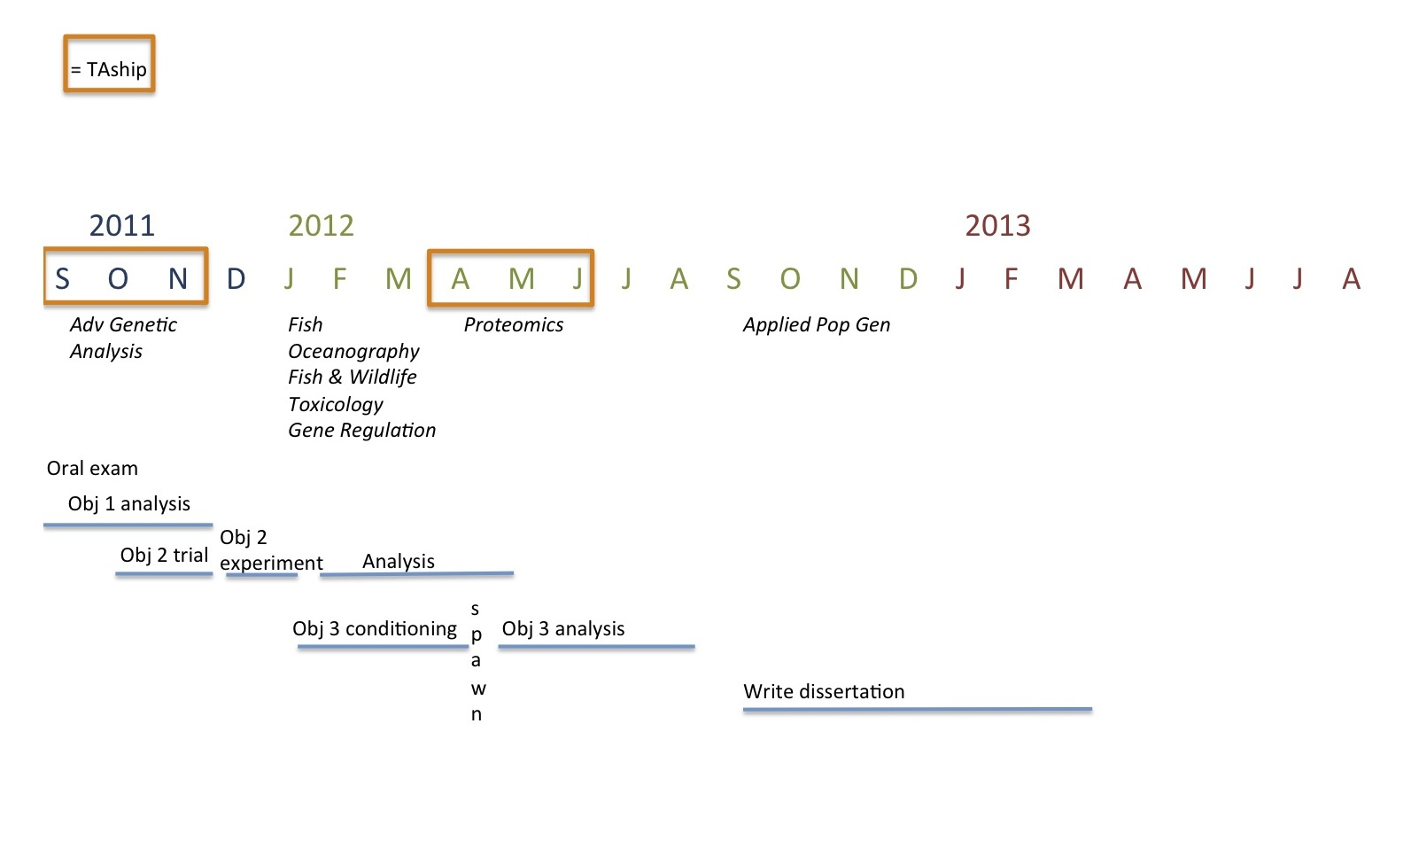

REFERENCES
Bechmann RK, IC Taban, S Westerlund, BF Godal, M Arnberg, S Vingen, A Ingvarsdottir, and T Baussant. 2011. Effects of ocean aciidification on early life stages of shrimp (Pandalus borealis) and mussel (Mytilus edulis). J Toxicol Environ Health A. 74 (7-9): 424-438.

Diffenbaugh, N.S., M.A. Snyder, and L.C. Sloan. 2004. Could CO2-induced land-cover feedbacks alter near-shore upwelling regimes? PNAS. 101(1): 27-32

Dupont S, J Havenhand, W Thorndyke, L Peck, and M Thorndyke. 2008. Near-future level of CO₂-driven ocean acidification radically affects larval survival and development in the brittlestar Ophiothrix fragilis. Mar Ecol Prog Ser. 373: 285-294.

Chapman RW, A Macia, M Beal, A Veloso, C Rathburn, A Blair, AF Holland, GW Warr, G Didinato, IM Sokolova, EF Wirth, E Duff, and D Sanger. 2011. The transcriptomic responses of the eastern oyster, Crassostrea virginica to environmental conditions. Mol Ecol. 20(7): 1431-1499.

Clegg JS, KR Uhlinger, SA Jackson, GN Cherr, E Rifkin, CS Friedman. 1998. Induced thermotolerance and heat shock protein-70 family in the Pacific oyster Crassostrea gigas. Mol Mar Biol and Biotech. 7(1): 21-30.

Cummings V, J Hewitt, A Van Rooyen, K Currie, S Beard, S Thrush, J Norkko, N Barr, P Heath, NJ Halliday, R Sedcole, A Gomez, C McGraw, and V Metcalf. 2010. Ocean acidificaiotn at high latitudes: potential effects on functioning of the Antarctic bivalve Laternula elliptica. PLoS ONE. 6(1): e16069.doi:10.1371/journal.pone.0016069.

Dickson, A.G., C.L. Sabine, and J.R. Christian. 2007. Guide to best practices for ocean CO2 measurements. Guide to best practices for ocean CO2 measurements, Sidney, British Columbia. North Pacific Marine Science Organization, (PICES Special Publication, 3)

DOE (Washington Department of Ecology). 2011. Control of Toxic Chemicals in Puget Sound: Phase 3 Data and Load Estimates. Publication No. 11-03-010. Prepared by Herrera Environmental Consultants, Inc. April 2011. Olympia, WA.

Elston R, and L Leibovitz. 1980. Pathogenesis of experimental Vibriosis in larval American oysters, Crassostrea virginica. Can J Fish Aquat Sci. 37: 964-978.

Fabry, V.J., B.A. Seibel, R.A. Feely, and J.C. Orr. 2008. Impacts of ocean acidification on marine fauna and ecosystem processes. ICES Journal of Marine Science. 65: 414-432.

Fassbender AJ, CL Sabine, RA Feely, C Langdon, and CW Mordy. 2011. Inorganic carbon dynamics during northern California coastal upwelling. Continental Shelf Research. 31(11): 1180-1192.

Faurby S, TL King, M Obst, EM Hallerman, C Pertoldi, and P Funch. 2010. Population dynamics of American horseshoe crabs – historic climatic events and recent anthropogenic pressures. Mol Ecol. 19(15): 3088-3100.

Feely, R.A., S.R. Alin, J. Newton, C.L. Sabine, M. Warner, A. Devol, C. Krembs, and C. Maloy. 2010. The combined effects of ocean acidification, mixing, and respiration on pH and carbonate saturation in an urbanized estuary. Estuarine, Coastal, and Shelf Science. 88(4): 442-449.

Findlay HS, MA Kendall, JI Spicer, and S Widdicombe. 2009. Future high CO2 in the intertidal may compromise adult barnacle Semibalanus balanoides survival and embryonic development rate. Mar Ecol Prog Ser. 389: 193-202.

Gutowska MA, F Melzner, M Langenbuch, C Bock, G Claireaux, and HO Portner. 2010. Acid-base regulatory ability of the cephalopod (Sepia officinalis) in response to environmental hypercapnia. J Comp Phys B. 180(3): 323-335.

Hauri, C., N. Gruber, G.-K. Plattner, S. Alin, R.A. Feely, B. Hales, and P.A. Wheeler. 2009. Ocean acidification in the California Current system. Oceanography. 22(4): 60-71.

Hernroth B, S Baden, M Thorndyke, and S Dupont. 2011. Immune suppression of the echinoderm Asterias rubens (L.) following long-term ocean acidification. Aquat Toxicol. 103(3-4): 222-224.

IPCC (Intergovernmental Panel on Climate Change) 2007. Contribution of Working Groups I, II, and III to the Fourth Assessment Report of the Intergovernmental Panel on Climate Change. R.K. Pachauri and A. Reisinger (Eds). IPCC, Geneva, Switzerland. pp 104.

Jeukens. J., S. Renaut, J. St.-Cyr, A.W. Nolte, and L. Bernatchez. 2010. The transcriptomics of sympatric dwarf and normal lake whitefish (Coregonus clupeaformis spp., Salmonidae) divergence as revealed by next-generation sequencing. Molecular Ecology. 18(24): 5389-5403.

King, J. R., Agostini, V. N., Harvey, C. J., McFarlane, G. A., Foreman,M. G. G., Overland, J. E., Di Lorenzo, E., Bond, N. A., and Aydin, K. Y. 2011 (in press, online only) Climate forcing and the California Current ecosystem. ICES Journal of Marine Science.

Kurihara H, S Kato, and A Ishimatsu. 2007. Effects of increased seawater pCO2 on early development of the oyster C.rassostrea gigas. Aquat Biol. 1:91-98.

Lannig G, S Eilers, HO Portner, IM Sokolova, and C Bock. 2010. Impact of ocean acidification on energy metabolism of oyster, Crassostrea gigas – changes in metabolic pathways and thermal response. Mar Durgs. 8(8): 2318-2339.

Letendre J, M Dupont-Rouzeyroi, A-C Hanquet, F Durand, H Budzinski, P Chang, D Vaudry, and B Rocher. in press. Impact of toxicant exposure on proteomic response to intertidal condition in Mytilus edulis. Comp Biochem and Phys D. doi:10.1016/j.cbd.2011.08.002.

Li Q, M Osada, and K Mori. 2000. Seasonal biochemical variations in Pacific oyster gonadal tissue during sexual maturation. Fisheries Science. 66(3): 502-508.

Liew M, R Pryor, R Palais, C Meadows, M Eralie, E Lyon, and C Wittwer. 2004. Genotypig of single-nucleotide polymorphisms by high-resolution melting of small amplicons. Clinical Chemistry. 50: 1156-1164.

Lischka S, J budenbender, T Boxhammer, and U Riebesell. 2011. Impacted of ocean acidification and elevated temperatures on early juveniles of the polar shelled pteropod Limacina helicina: mortality, shell degradatation, and shell growth. Biogeosciences. 8: 919-932.

Lockwood, B.L. and G.N. Somero. 2011. Transcriptomic responses to salinity stress in invasive and native blue mussel (genus Mytilus). Molecular Ecology. 20(3): 517-529.

Marchant MK, P Calosi, and JI Spicer. 2010. Short-term exposure to hypercapnia does not compromise feeding, acid-base balance or respiration of Patella vulgata but surprisingly is accompanied by radula damage. J Mar Biol Assoc UK. 90: 1379-1384.

Martin S, Richler S, ML Pedrotti, S Dupont, C Castejon, Y Gerakis, ME Kerros, F Oberhansil, JL Teyssie, R Jeffree, and JP Gattuso. 2011. Early development and molecular plasticity in Mediterranean sea urchin Paracentrotus lividus exposed to CO2-driven acidification. J Exp Biol. 214(Pt 8): 1357-68.

Miles H, S Widdicombe, JI Spicer, and J Hall-Spencer. 2007. Effects of anthropogenic seawater acidification on acid-base balance in the sea urchin Psammechinus miliaris. Mar Poll Bull. 54(1); 89-96.

Mote, P.W., A. Petersen, S. Reeder, H. Shipman, and L.C. Whitely Binder. 2008. Sea Level Rise in the Coastal Waters of Washington State. Report prepared by the Climate Impacts Group, Center for Science in the Earth System, Joint Institute for the Study of the Atmosphere and Oceans, University of Washington, Seattle, Washington and the Washington Department of Ecology, Lacey, Washington.

Parker LM, PM Ross, and WA O’Connor. 2010. Comparing the effect of elevated pCO2 and temperature on the fertilization and early development of two species of oysters. Mar Biol. 157(11): 2435-2452.

Parker LM, PM Ross, WA O’Connor, L Barysko, DA Raftos, and HO Portner. in press. Adult exposures influences offspring response to ocean acidification in oysters. Global Change Biol. Doi: 10.1111/j.1365-2486.2011.02520.x

Penkman KEH, DS Kaufman, D Maddy, and MJ Collins. 2008. Closed-system behaviour of the intra-crystalline fraction of amino acids in mollusc shells. Quaternary Geochronology. 3(1-2): 2-25.

Pörtner, H.O., M. Langenbuch, and A. Reipschlager. 2004. Biological impact of elevated CO2 concentrations: lessons learned from animal physiology and earth history. Journal of Oceanography. 60(4): 705-718.

Puget Sound Partnership (PSP). 2008. Puget Sound – Where land and sea meet. Retrieved from http://www.psparchives.com/puget_sound.htm.

Réale, D., A.G. McADam, S. Boutin, and D. Berteaux. 2003. Genetic and plastic responses of a northern mammal to climate change. Proc.R.Soc.Lond.B. 270(1515): 591-596.

Ries JB. 2011. A physicochemical framework for interpreting the biological calcification response to CO2-induced ocean acidification. Geochimica et Cosmochimica Acta. 75(14): 4053-4064.

Rodriguez-Lanetty M, S Harii, and O Hoegh-Guldberg. 2009. Early molecular responses of coral larvae to hyperthermal stress. Mol Ecol. 18(24): 5101-5114.

Sauvage C, N Bierne, S Lapegue, and P Boudry. 2007. Single nucleotide polymorphisms and their relationship to codon usage bias in the Pacific oyster Crassostrea gigas. Gene. 406(1-2): 13-22.

Shaw BL and HI Battle. 1957. The gross and microscopic anatomy of the digestive tract of the oyster Crassostrea virginica (Gmelin). Can J Zool. 33(3): 325-347.

Shofer SL and RS Tjeerdema. 1993. Comparative disposition and biotransformation of pentachlorophenol in the oyster (Crassostrea gigas) and abalone (Haliotis fulgens). Pesticide Biochemistry and Physiology. 46(2): 85-95.

Spicer JI, A Raffo, and S Widdicombe. 2007. Influence of CO2-related seawater acidification on extracellular acid-base balance in the velvet swimming crab Necora puber. Mar Biol. 151(3): 1117-1125.

Storey JD. 2002. A direct approach to false discovery rates. J.R. Statist Soc B. 64(3): 479-498.

Stumpp M, J Wren, F Melzner, MC Thorndyke and ST Dupont. 2011a. CO2 induced seawater acidification impacts sea urchin larval development I: elevated metabolic rates decrease scope for growth and induce developmental delay. Comp Biochem and Phys A. 160(3): 331-340.

Stumpp M, S Dupont, MC Thorndyke and F Melzner. 2011b. CO2 induced seawater acidification impacts sea urchin larval development II: gene expression patterns in pluteus larvae. Comp Biochem and Phys A. 160(3): 320-330.

Thomsen, J., and F. Melzner. 2010. Moderate seawater acidification does not elicit long-term metabolic depression in the blue mussel Mytilus edulis. Marine Biology. 157(12); 2667-2676.

Todgham AE and GE Hofmann. 2009. Transcriptomic response of sea urchin larvae Strongylocentrotus purpuratus to Co2-driven seawater acidification. J Exp Biol. 212: 2579-2594.

Tomanek L, MJ Zuzow, AV Ivanina, E Beniash, and IM Sokolova. 2011. Proteomic response to elevated pCO2 level in eastern oysters, Crassostrea virginica: evidence for oxidative stress. J Exp Biol. 214: 1836-1844.

Wang S, L Zhang, E Meyer, and MV Matz. 2009. Construction of a high-resolution genetic linkage map and comparative genome analysis for the reef-building coral Acropora millepora. Genome Biology. 10(11): doi:10.1186/gb-2009-10-11-r126.

Watson, S.-A., P.C. Southgate, P.A. Tyler, and L.S. Peck. 2009. Early larval development of the Sydney rock oyster Saccostrea glomerata under near-future predictions of CO2-driven ocean acidification. Journal of Shellfish Research. 29(3): 431-437.

Weinbach EC. 1954. The effect of pentachlorophenol on oxidative phosphorylation. J Biol Chem. 210: 545-550.

Wirgin, I., N.K. Roy, M. Loftus, R.C. Chambers, D.G. Franks, and M.E. Hahn. 2011. Mechanistic basis of resistance to PCBs in Atlantic tomcod from the Hudson River. Science. Doi: 10.11126/science.1197296.

Wong KKW, AC Lane, PTY Leung, and V Thiyagarajan. 2011. Response of larval barnacle proteome to CO2-driven seawater acidification. Comp Biochem and Phys D. 6(3): 310-321.

